**HOW TO USE THE SYSTEM**

Step 1: Log in.

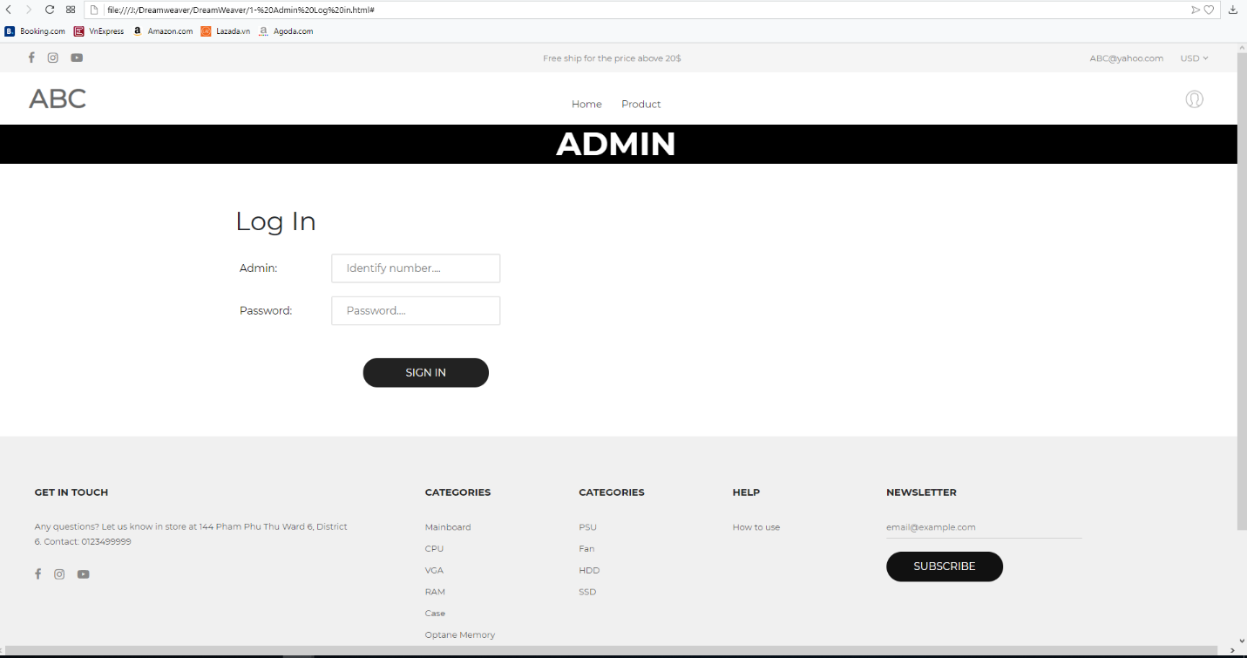

1

Step 2: After log into the system, you will join in admin screen, in this screen you will see all the changing whenever one product is changed, clicked into Product Fix to changed product’s information.

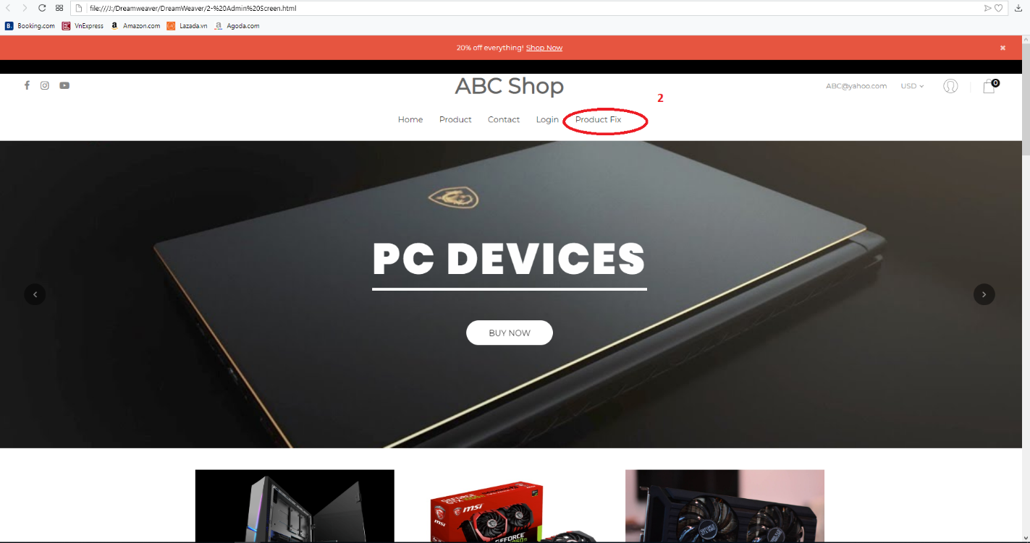

Step3: The correct page layout is easy to look and use.

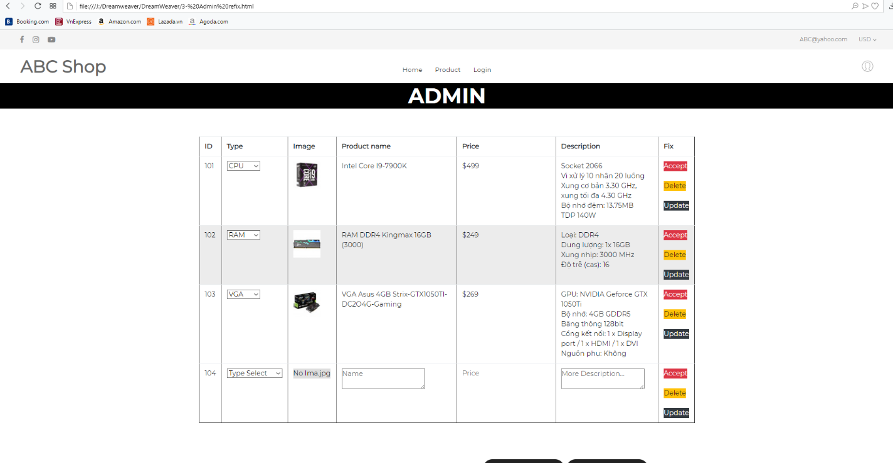

* Just click Update if the change is correct and cancel if you want to move back.

